How many 2D shapes can you find around your school??
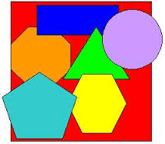
Name of 2-D Shape | Real Life Object

